
North Bengal International University

Lab Report: 1 01
Exp Name : A Program to Reduce Image Resolution Step by Step

Subject : Digital Image Processing sessional
Subject Code : CSE 0613-4142

Submitted By:
Name : Md. Tanvir Rahman Pranto
Dept : CSE
Roll : 0712340012101005
Semester : 3nd Year, 6th semester.

Submitted To:
Name : Sakurah Ismail
Designation : Lecturer
Dept : CSE

Experiment Title: A Program to Reduce Image Resolution Step by Step

Introduction: Image resolution refers to the number of pixels used to represent an image. Higher resolution provides more detail, while lower resolution reduces detail but decreases storage and processing requirements. In digital image processing, resolution reduction is often used for compression, scaling, or multi-resolution analysis. This experiment demonstrates how to iteratively reduce the resolution of a grayscale image by averaging pixel blocks, and then visualize the results at each stage.

Code:
import cv2
import matplotlib.pyplot as plt
import numpy as np

original_img = cv2.imread(
"/content/meaow.jpg",
cv2.IMREAD_GRAYSCALE
)

original_img = cv2.resize(original_img, (512, 512))

def decrease_resolution(image):
height, width = image.shape

new_height = height // 2
new_width = width // 2

decreased_img = np.zeros((new_height, new_width))

for i in range(new_height):
for j in range(new_width):
decreased_img[i, j] = np.mean(
image[i*2:(i*2)+2, j*2:(j*2)+2]
)

return decreased_img

dec_img = original_img.copy()

plt.figure(figsize=(16, 8))
for k in range(1, 7):
plt.subplot(2, 3, k)
plt.title(f"{dec_img.shape}")
plt.imshow(dec_img, cmap="gray")
plt.axis("off")
dec_img = decrease_resolution(dec_img)

plt.tight_layout()
plt.show()

Output :
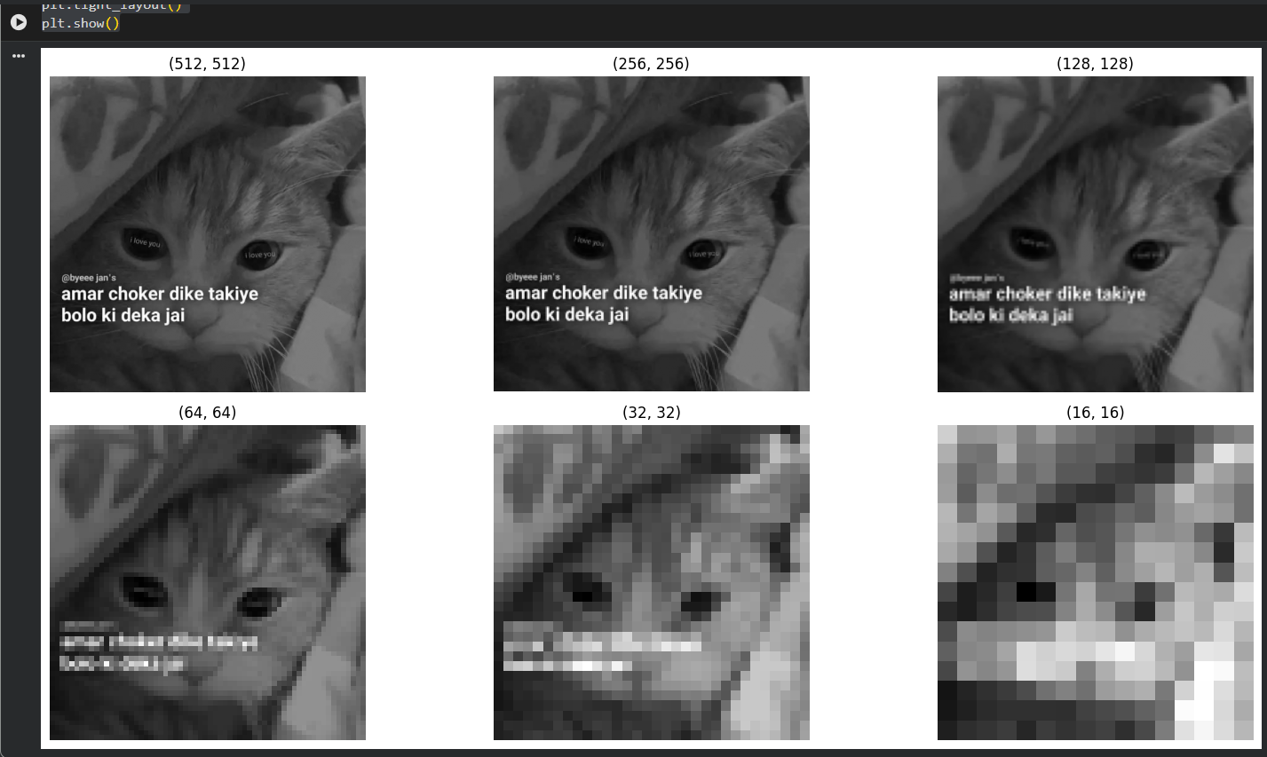

Discussion on the output: The program begins with a grayscale image resized to a fixed dimension. A custom function reduces resolution by dividing the image into non-overlapping 2×2 pixel blocks and replacing each block with its average intensity. This process is repeated multiple times, producing progressively smaller images. The output shows how resolution reduction affects image clarity: fine details are lost, but overall structure remains visible. Such techniques are useful in image compression, pyramid representation, and preprocessing for computer vision tasks where reduced data size improves efficiency.

